**Project 10- Developing an Application Using React Native**

Name: Harshad Pawar

Batch: IDFC-JFS-B2

Table of Contents:

|  |  |  |
| --- | --- | --- |
| **Sr. No.** | **Content** | **Page no.** |
| 1. | Introduction | 2 |
| 2. | Code | 2 |
| 3. | Technology Used | 4 |
| 4. | Output | 12 |
| 5. | Conclusion | 14 |

**Introduction**

**Aim**: Develop Application using react native. With Require Validation.

**Application Name:** Online Tours and Travel Agency

**Scope:**

Mobile app development for the tourism industry is a viable business proposition. Look at these figures to understand its penetration and possibilities –  
1. An increasing number of smartphone users depend on travel apps. More than 71% of them conduct weekly searches for new destinations.  
2. App stores from Google, Android, and Windows have high demand. Around 35% of users discover travel apps while browsing the stores.  
3. Travel apps with notifications and alerts are very famous. Close to 45% of users find travel status updates to be a convenient feature.  
4. You can build mobile apps without worrying about market success. Demand for new products is high, as 29% of users discard older, inefficient travel apps.  
5. The millennial generation has very high smartphone usage. Nearly 58% of travel-related searches every week take place via mobile.

The mobile travel trends for the next few years are also promising. New technologies like AI and virtual reality are gaining a foothold. The next-gen travelers also seek visual searches and data-intensive information. They keen on progressive web apps as well as conversational UI  
These growth factors point towards a higher demand shortly. The scope of mobile app development for tourism has never been more promising. Here are a few more interesting statistics that will pique the minds of software developers –  
● 22% of mobile travel searches are about multimedia, knowledge graphs.  
● Around 15% to 23% of mobile users look for maps and tourism images.  
● The top 3 search results for the flight market own 52.6% of the airline market.

● 43% of users book a trip using brand travel apps that deliver stunning UX.  
● 30% to 40% of users download travel apps for speed and functionality.  
● 26% prefer mobile apps that do not require Internet connectivity.

**Technologies Used:**

1. Development Tool : React Native.
2. Performance Testing Tool : JMeter.
3. Backend : Spring Boot.
4. Database : MongoDB.

**Code:**

**Git Repository Link:**

[**https://github.com/Harshad0018/Capstone-Project.git**](https://github.com/Harshad0018/Capstone-Project.git)

**Output:**

This is login page of my application in this there are two fields Mobile Number and Pin. And it includes two buttons like Login and Sign up. So first we will start with sign up to create new account.

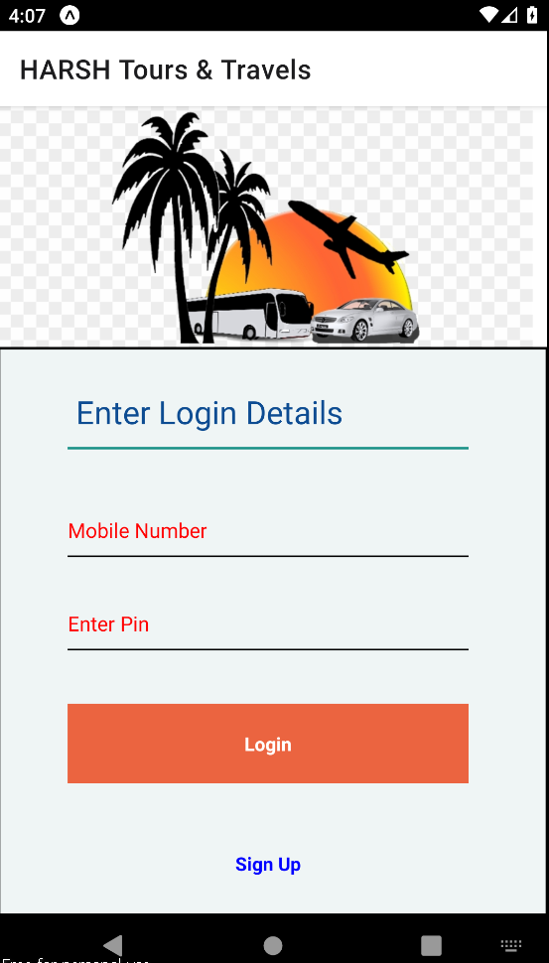

After clicking on sign up button it will redirect to the create new account page. It includes Five Fields such as Mobile Number, Name, Email, Enter Pin And Conform Pin and one sign in button.

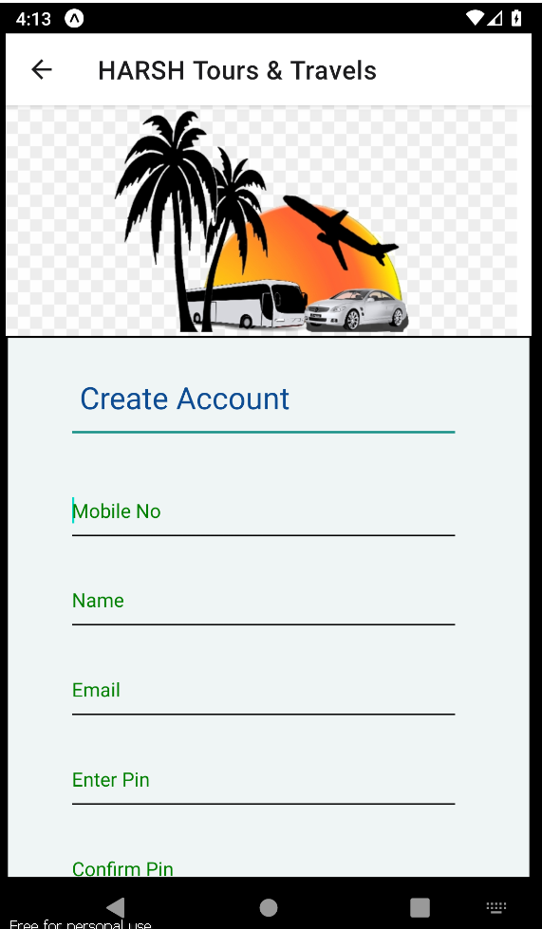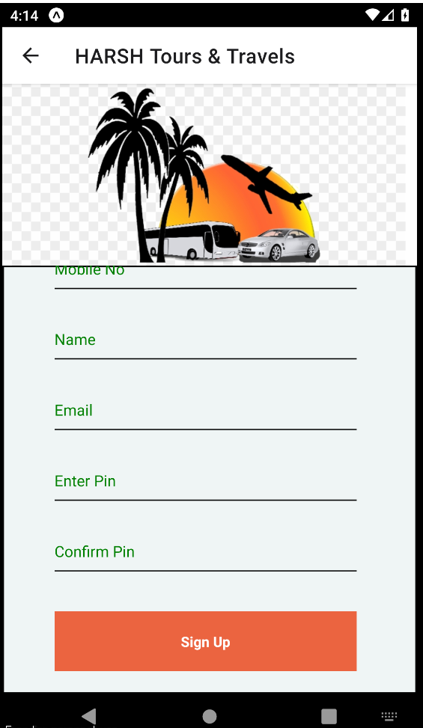

To Create New Account Enter All details, To this five Fields there is validations.

1. Mobile Number Should be 10 digits if I Enter mobile number with only 9 digits then it will show the alert.

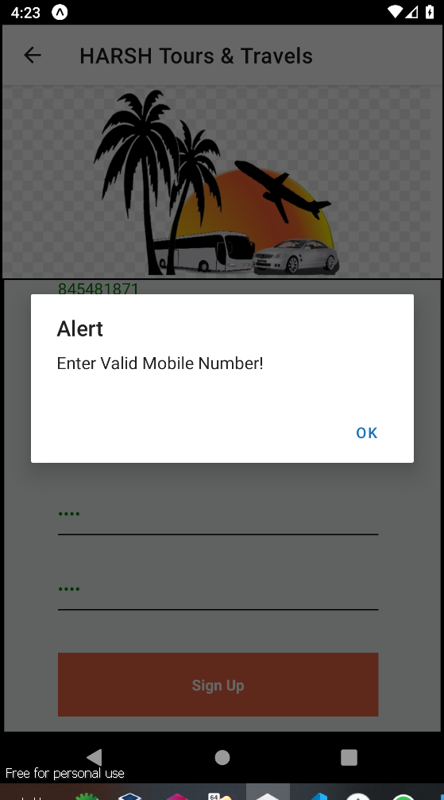

1. Name Validation:

Name Should contain Character if I enter Digit in Name field then it will show the error alert:

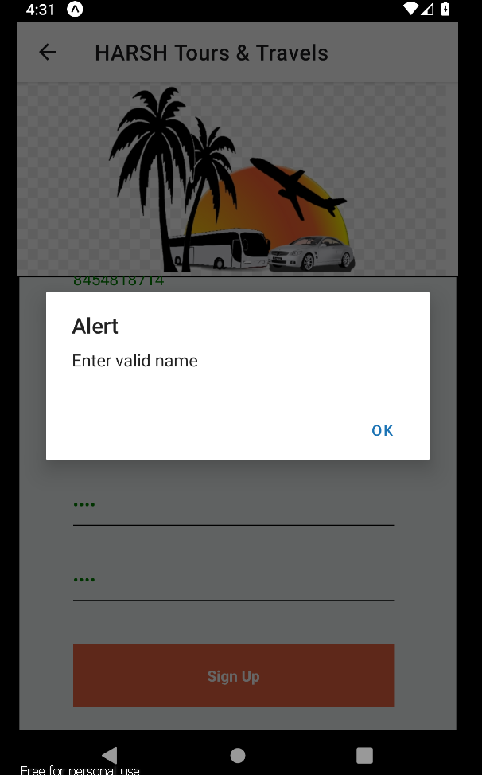

1. Email Validation:

Email Should be proper Email formant It should include “@” and “.”

If I enter mail without “@” or “.” It will show the alert:

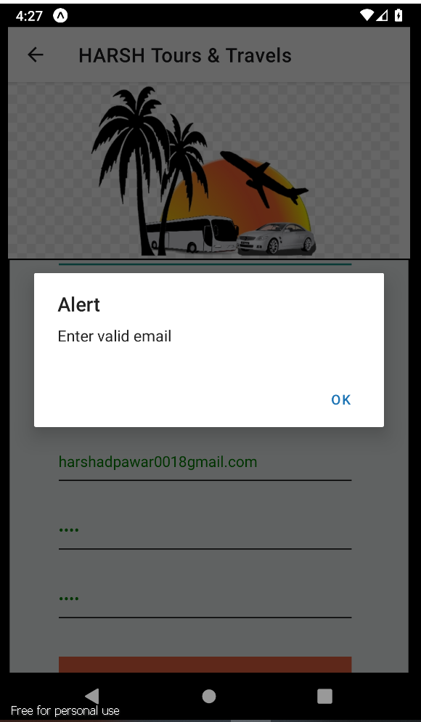

1. Pin Validation:

Pin should include at least four digits if I enter Pin with 3 digits then it will show error:

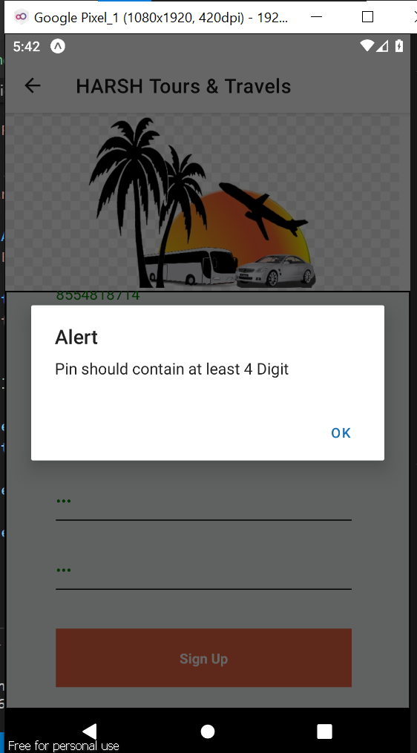

1. Conform Pin Validation:

Both password need to be match:

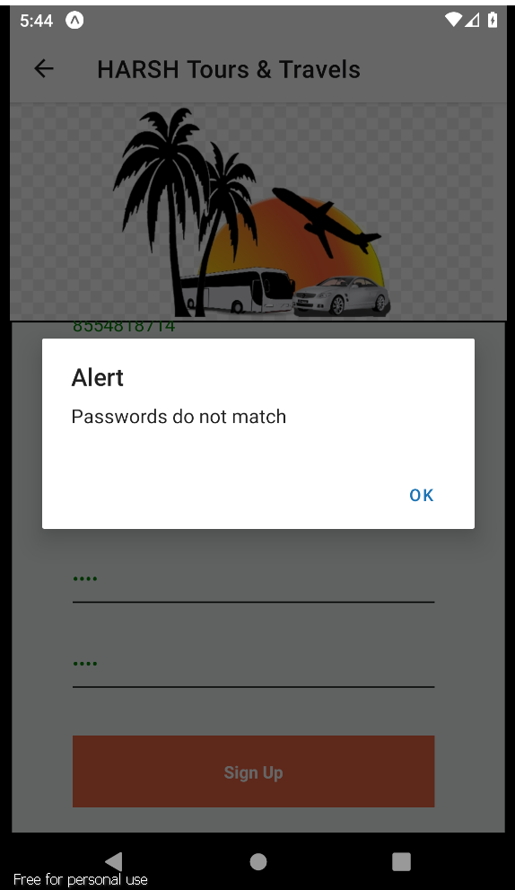

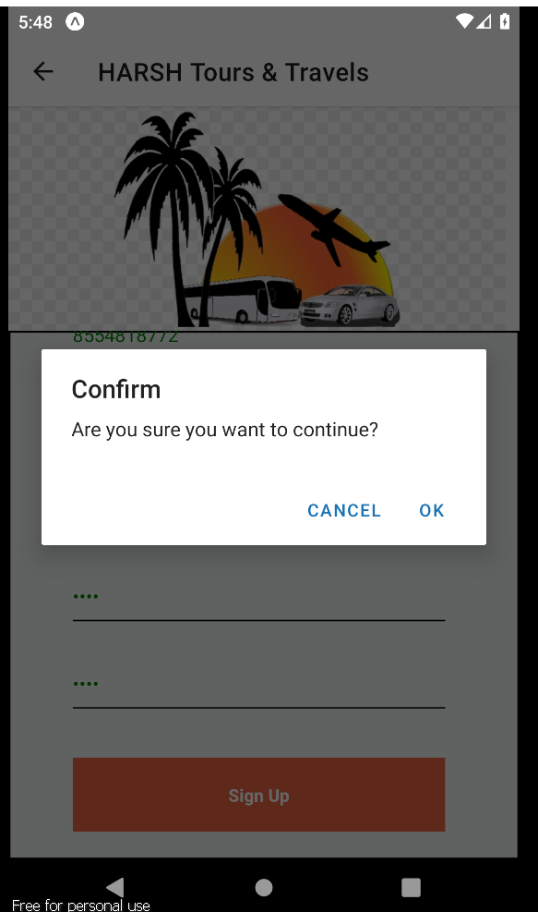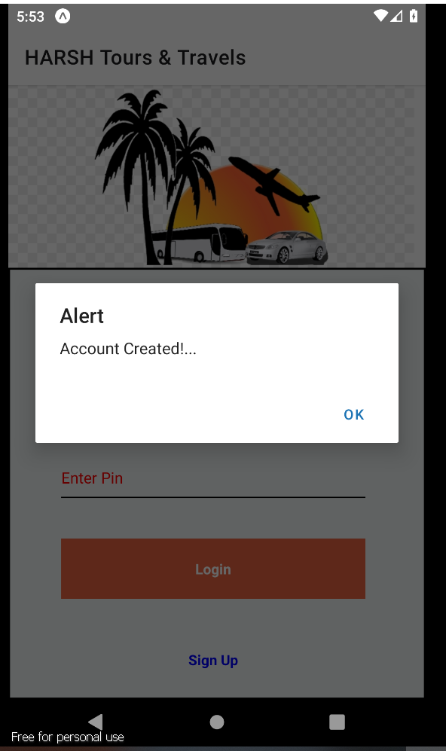If I Enter All the Details in valid format, and after clicking on sign up button it will ask for conformation with one alert “are you sure you want to continue” after clicking on ok again one alert will pop up with message “Account Created” the account will be get created successfully. And It will Navigate to Login Page for sign in into account.

For Login There is also validation:

The Mobile number and the Pin should be match it should be same as used at time of account creation.

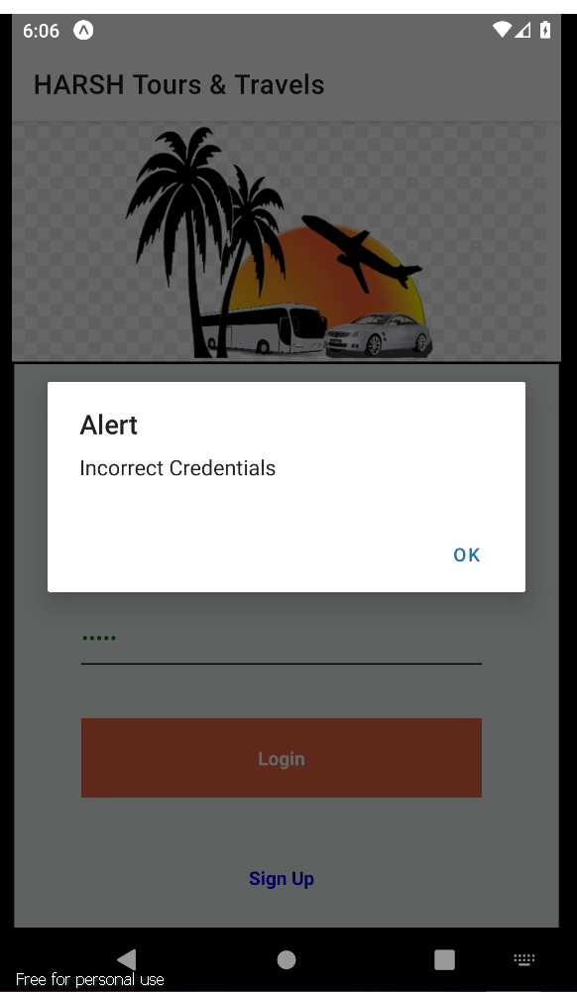

After Entering Valid Detail it will show one Welcome Message and Redirect to the Home page of the application:

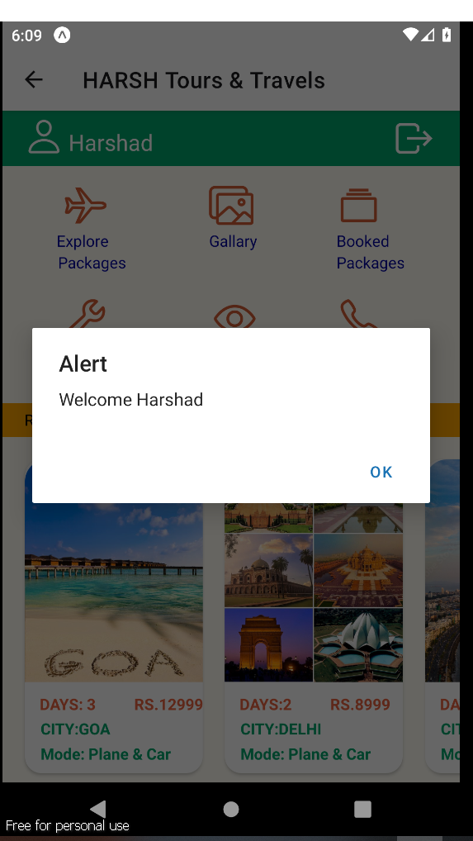

At Home Page there are Buttons with Icons like Explore Packages, Gallery, Booked Packages, Review and Contact Buttons and also the Recommended packages and Logout button.

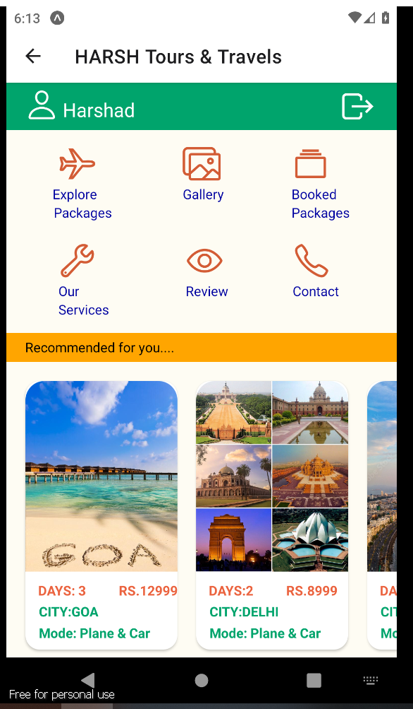

After Clicking on Explore Package Button Icon it will redirect to package Explore page as shown below, In Available Packages there are lots of packages shown with the Amount total days and the Mode of Transports.

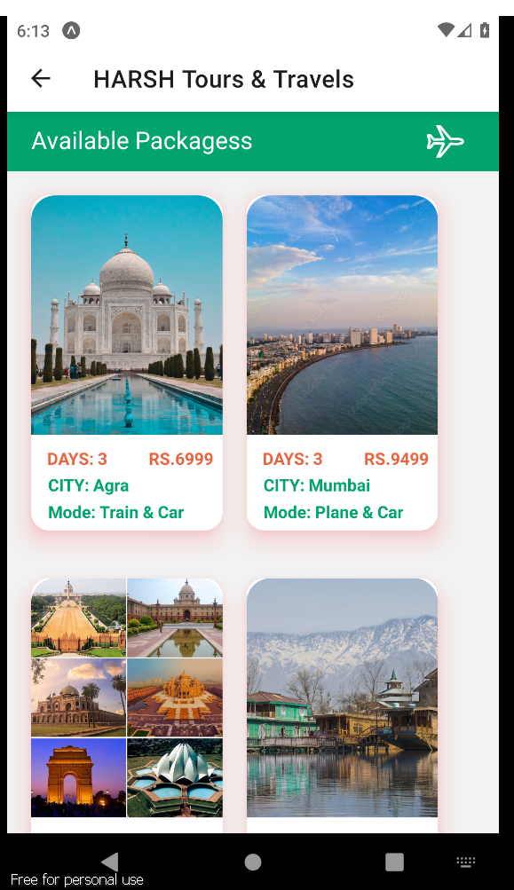

Available Packages:

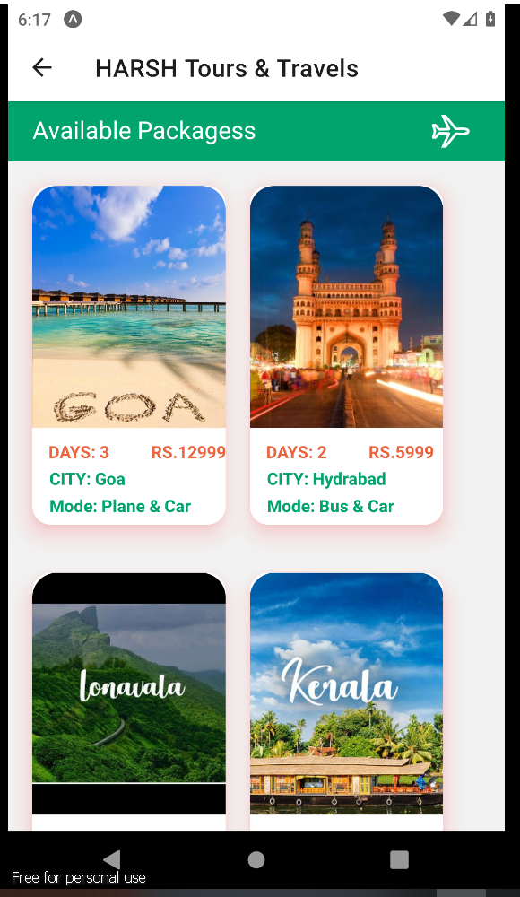

After Selecting The Package it will redirect to the Booking page :

In Booking Page there are Default package details and two input fields first is select members and second is choose arrival date and on proceed button

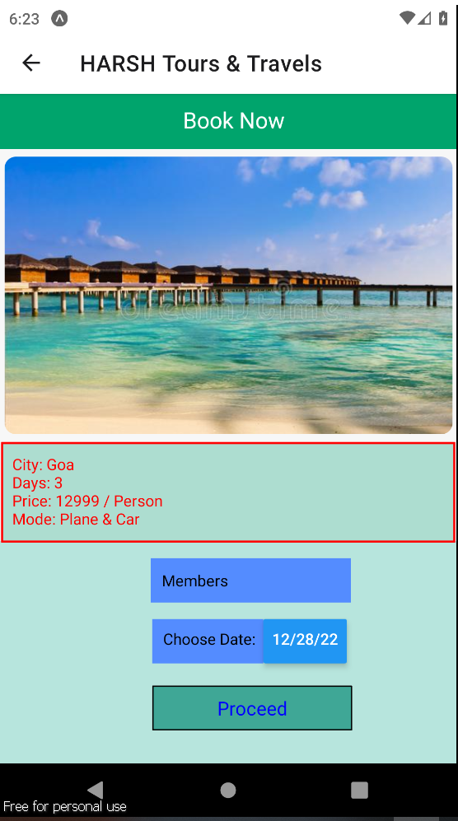

For Date There is validation Date should be grater than todays days and member field should not be empty:

If this data is wrong then it will shows error alert:

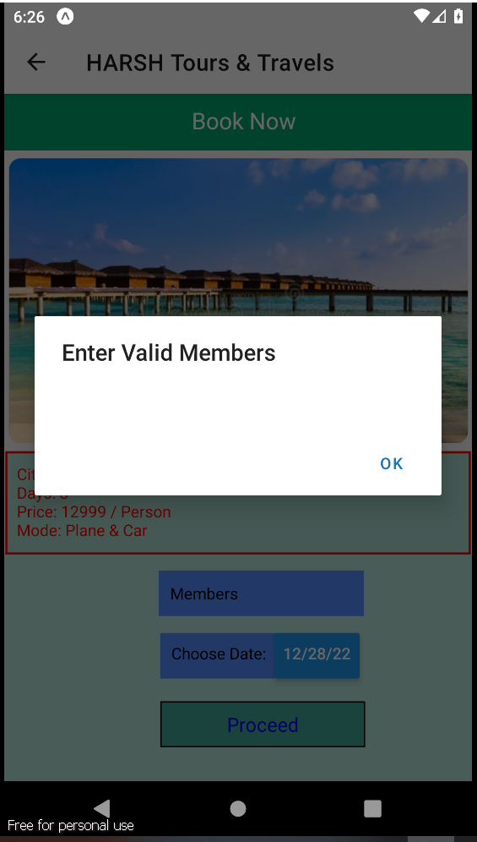

Date Validation: Date Should be Greater than or equal to todays date:

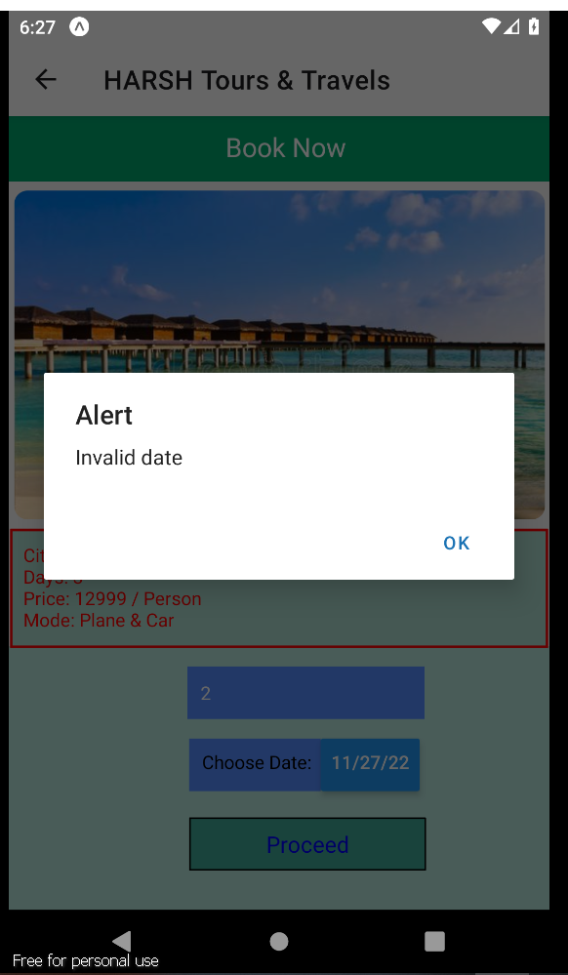

After Entering Valid details it will redirect to the Payment Page in payment page there are two fields one is ATM number and second is Pin. And one Pay button.

And at top the total amount will be displayed. According to package and the total members selected :

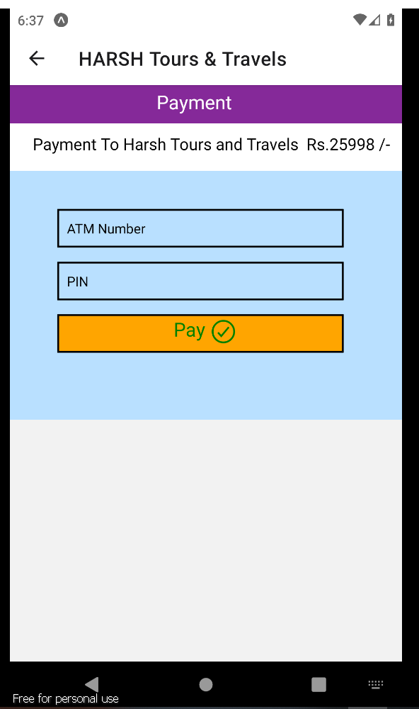

In Payment There are validations such as ATM number need to be 16 digit and pin should include 4 digits:

If I enter Card Number more than or less than 16 digit or Pin less than or more than 4 digit it will show the error alert ‘Enter Valid Details’

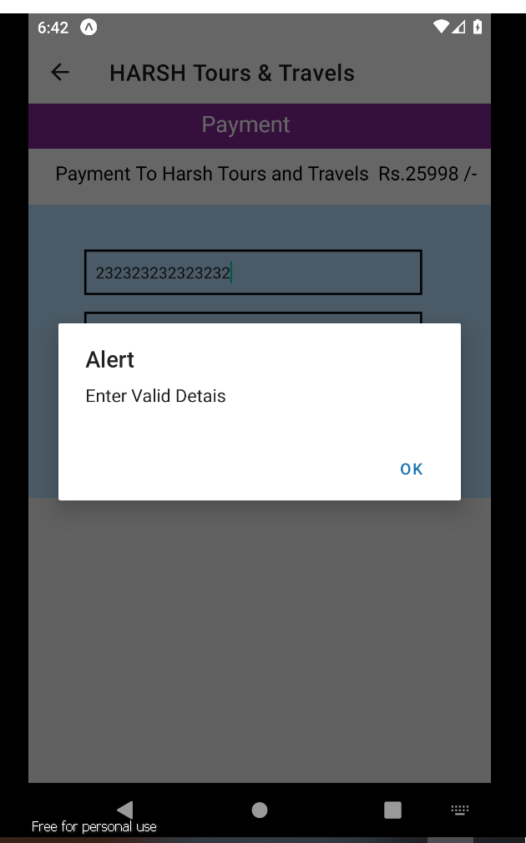

If Entered Details are Right and if I clicked on Pay Button then it will ask for conformation “Are you sure you want to continue” :

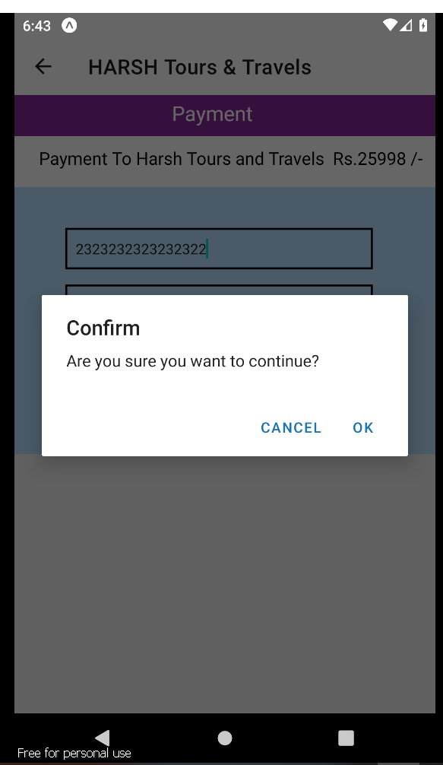

After Clicking on ok button the package will be booked successfully, and it will show one Alert message “Booked Successfully” then just click on that ok button.

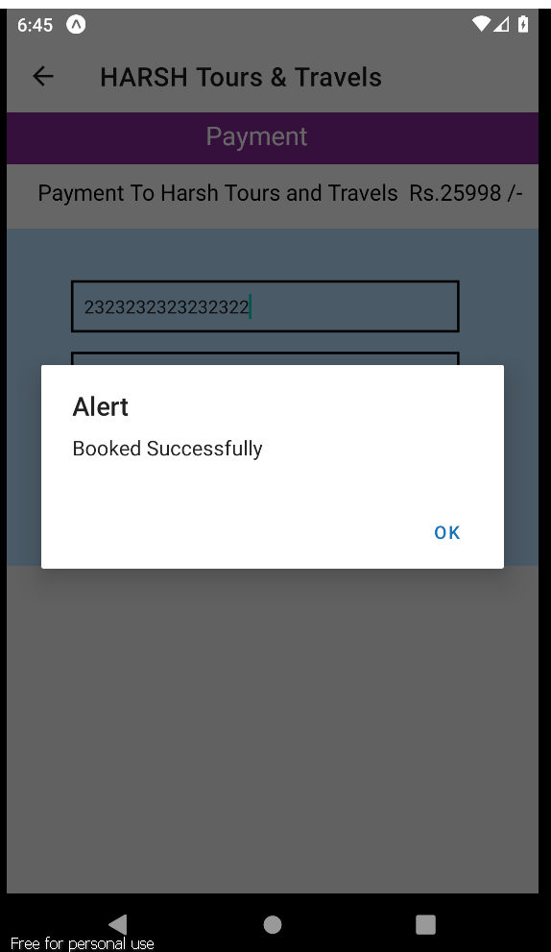

To View this Booked Packages go to Home Screen and Click on Booked Packages Button. After Clicking on Booked Packages It will Redirect to the below page

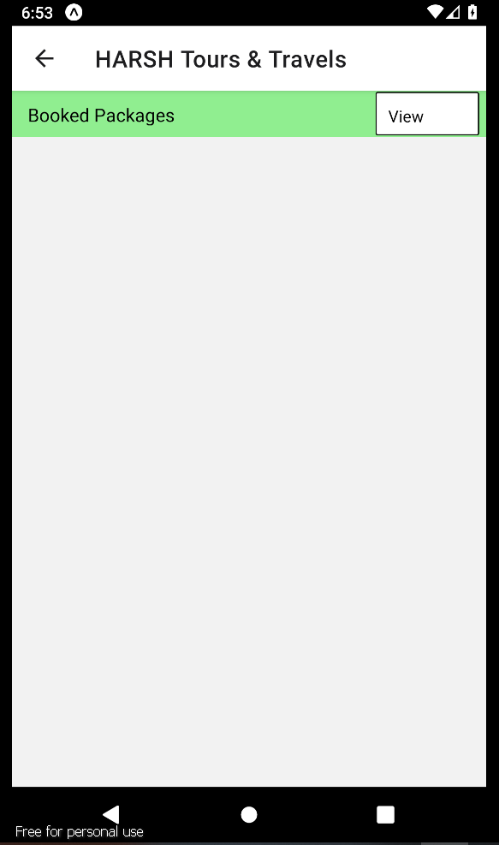

After Clicking on view Button it will show all the booked packages:

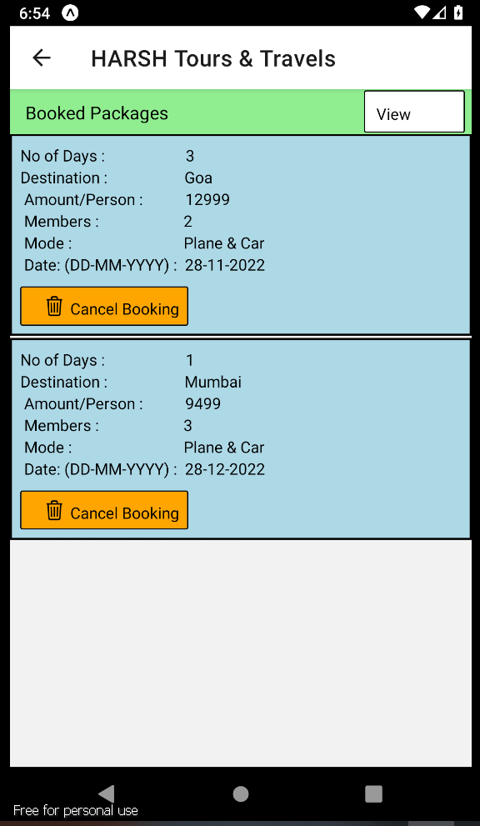

You can cancel bookings by clicking on cancel booking button :

So here after clicking on cancel booking for Mumbai it gets cancelled and here is only one package is remains:

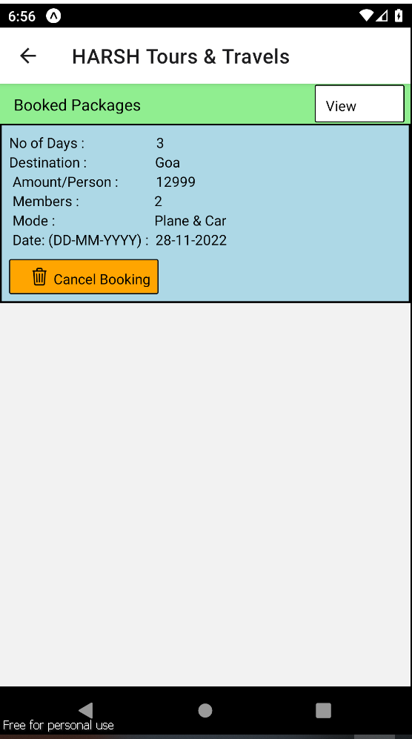

Again go to Home page and Click on Our Services Button It will shows the all the Services provided:

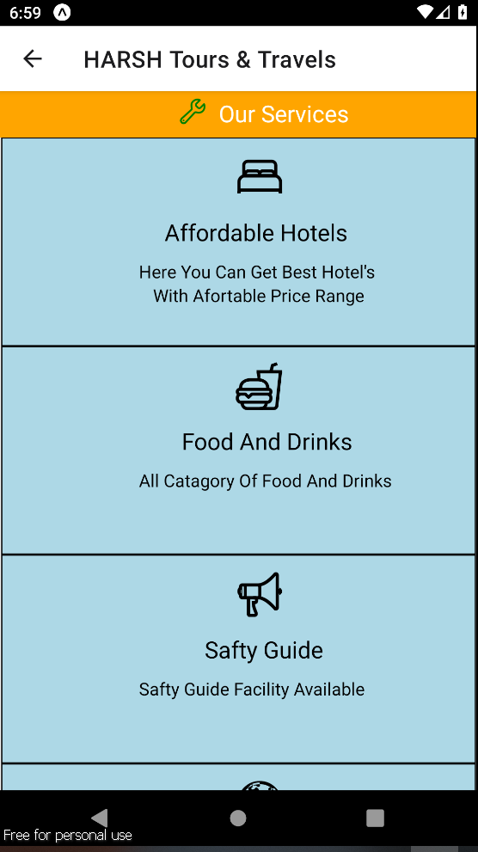

Scroll down For More:

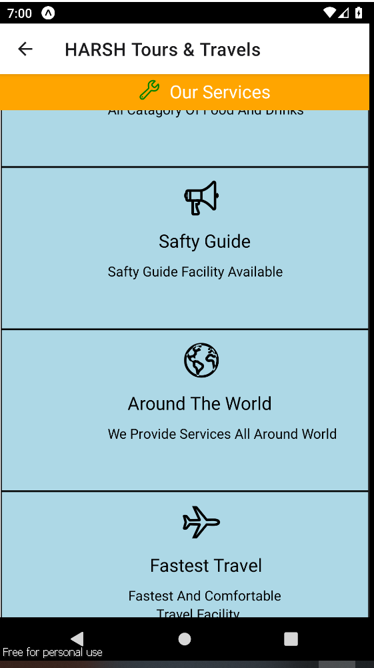

At Home screen there is Review Button after clicking on that it will redirect to the below page:

In that there are Three input Fields as shown below.

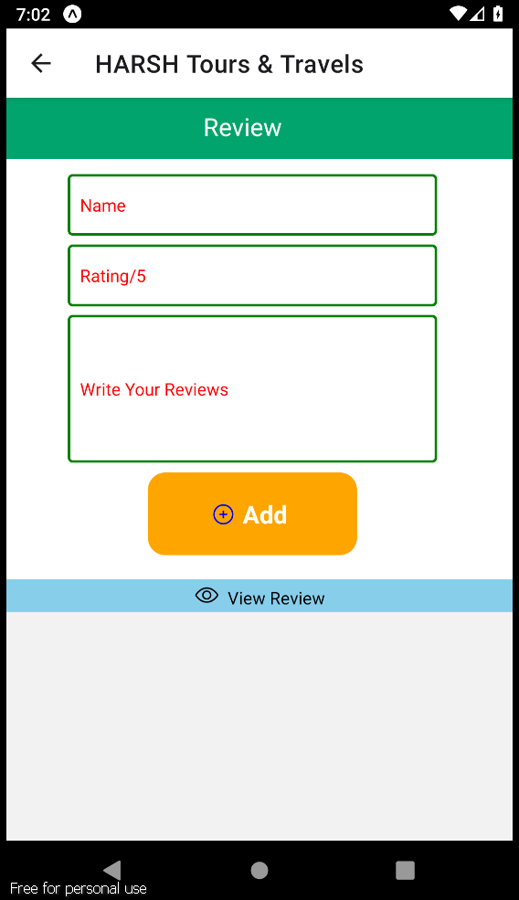

For This there is validation like Rating should be in scale of 1-5 and no Field should be Empty:

If I Enter Invalid Details it will show the Error:

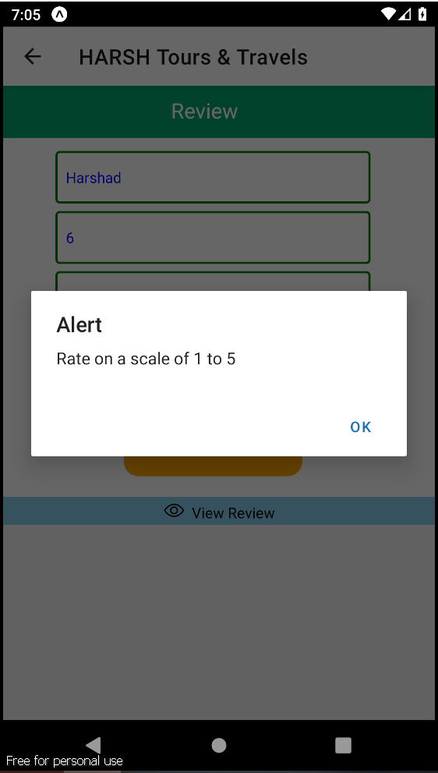

After Entering Valid data And clicking on the add button It will Show the alert “Review added” and review will get added.

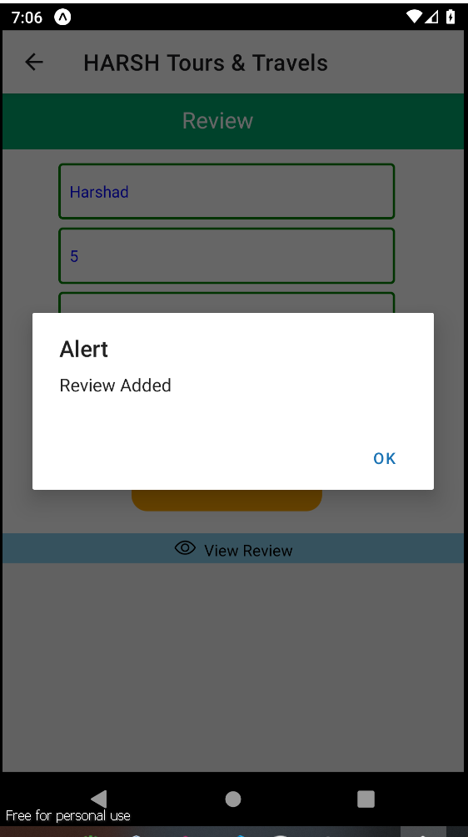

To View this Review Click on View Review Button and the all the reviews will be shown below. Scroll Down to view more reviews.

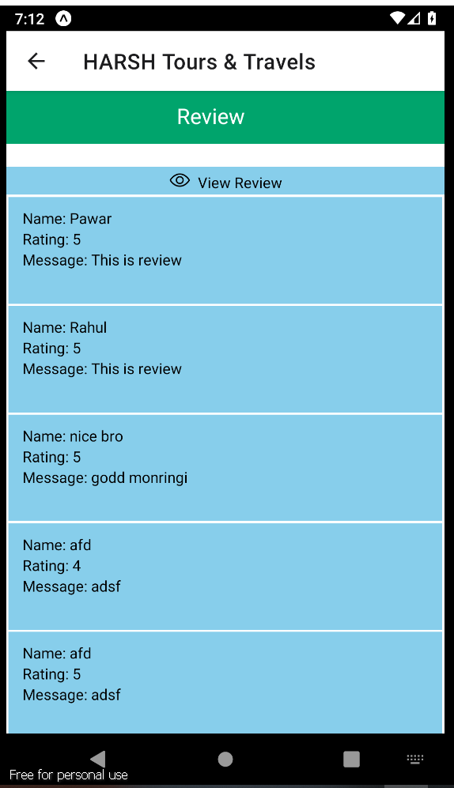

At Home There is contact us button after clicking on that it will redirect to the contact us page in that there is contact details to contact us.

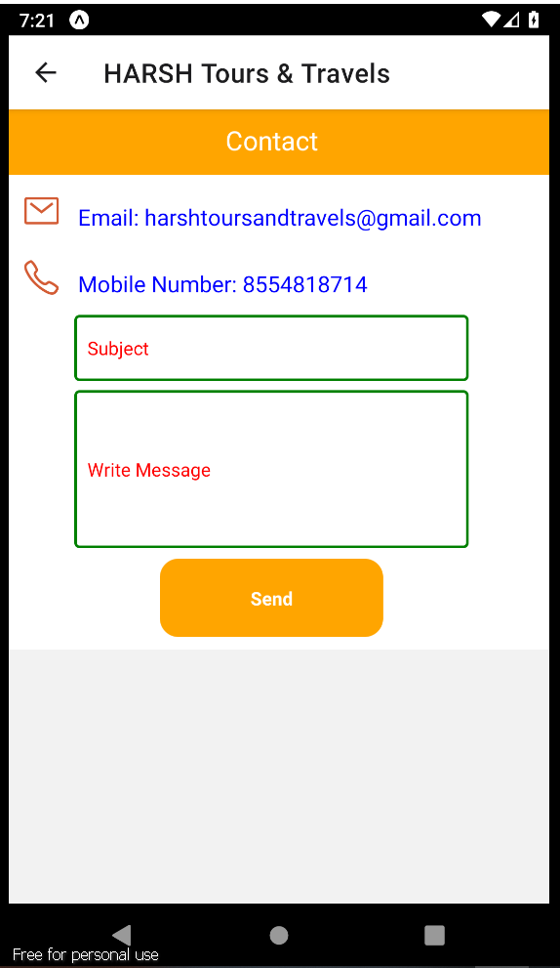

In these Page there are two Input Field like Subject and Write Message:

For this there is validation no fields should be empty:

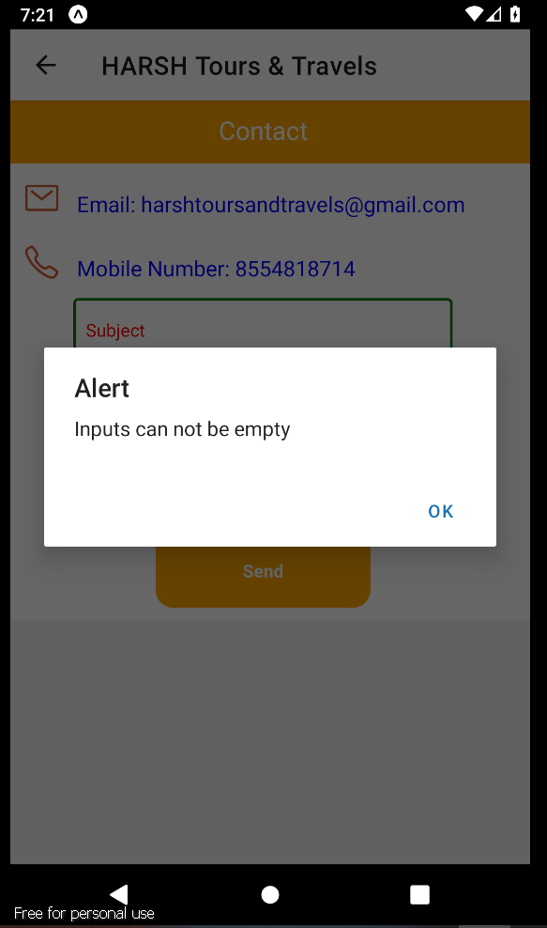

After Entering All the Input And Clicking on send button the message will be sent successfully and shows the alert “Message sent!... we will try to response ASAP” and the message will be added to database;

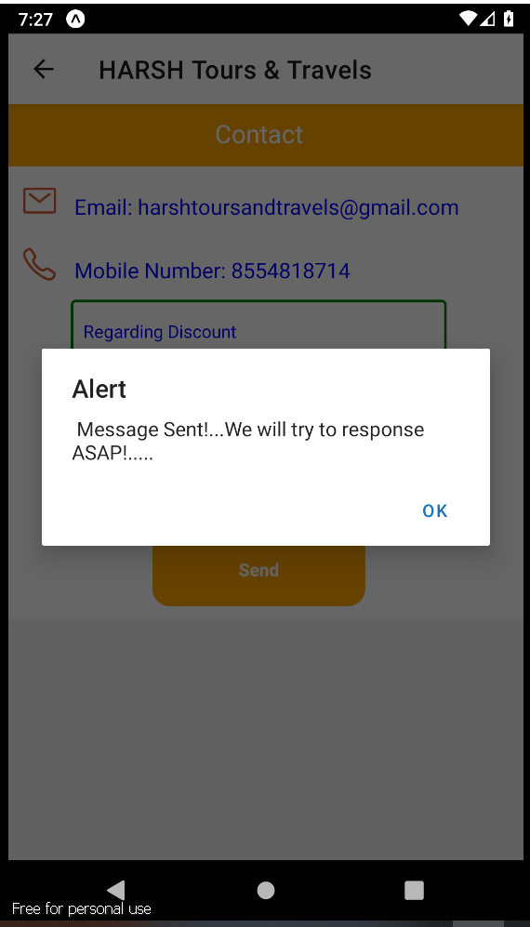

At Home Screen There is One button Gallery for Gallery View in this Gallery All the Images added by the users which clicked at time of tour:

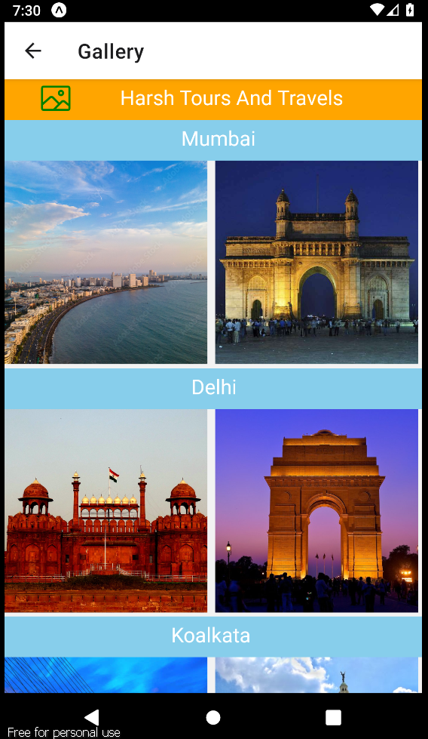

Scroll Down to View More

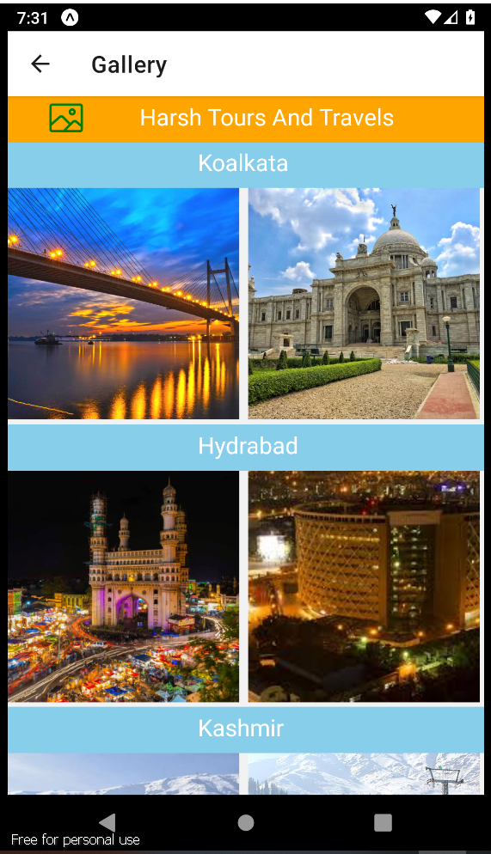

At Home there is recommended packages for users, After clicking on that it will redirect to the book option as we saw above:

Scroll Horizontal to view More :

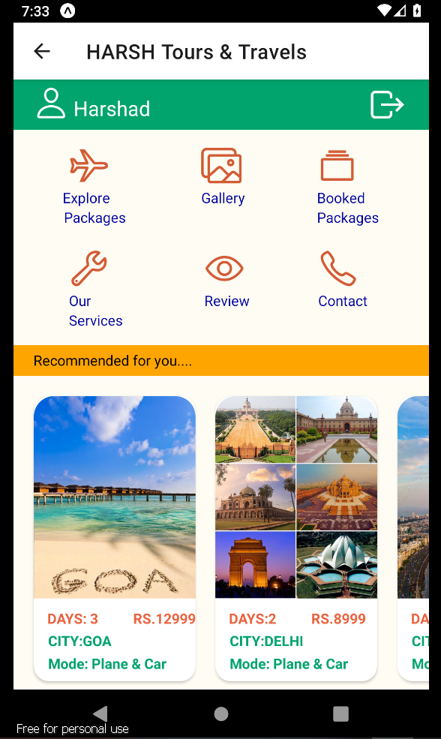

There is Logout Button at Top Right Corner After Clicking on that it will redirect to the Login page and user get Logged Out:

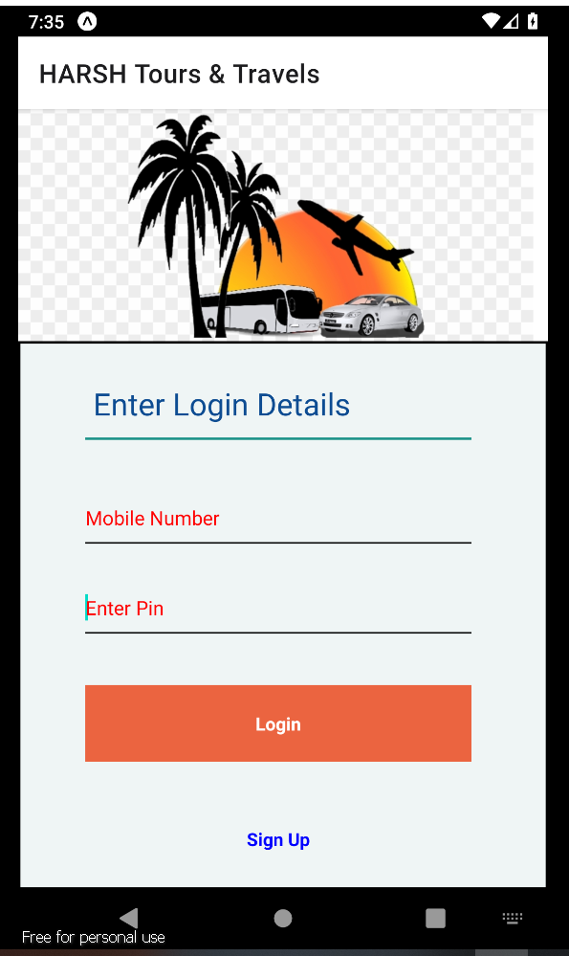

**Jmeter Testing:**

**API Test for Create user** (POST Method)**:**

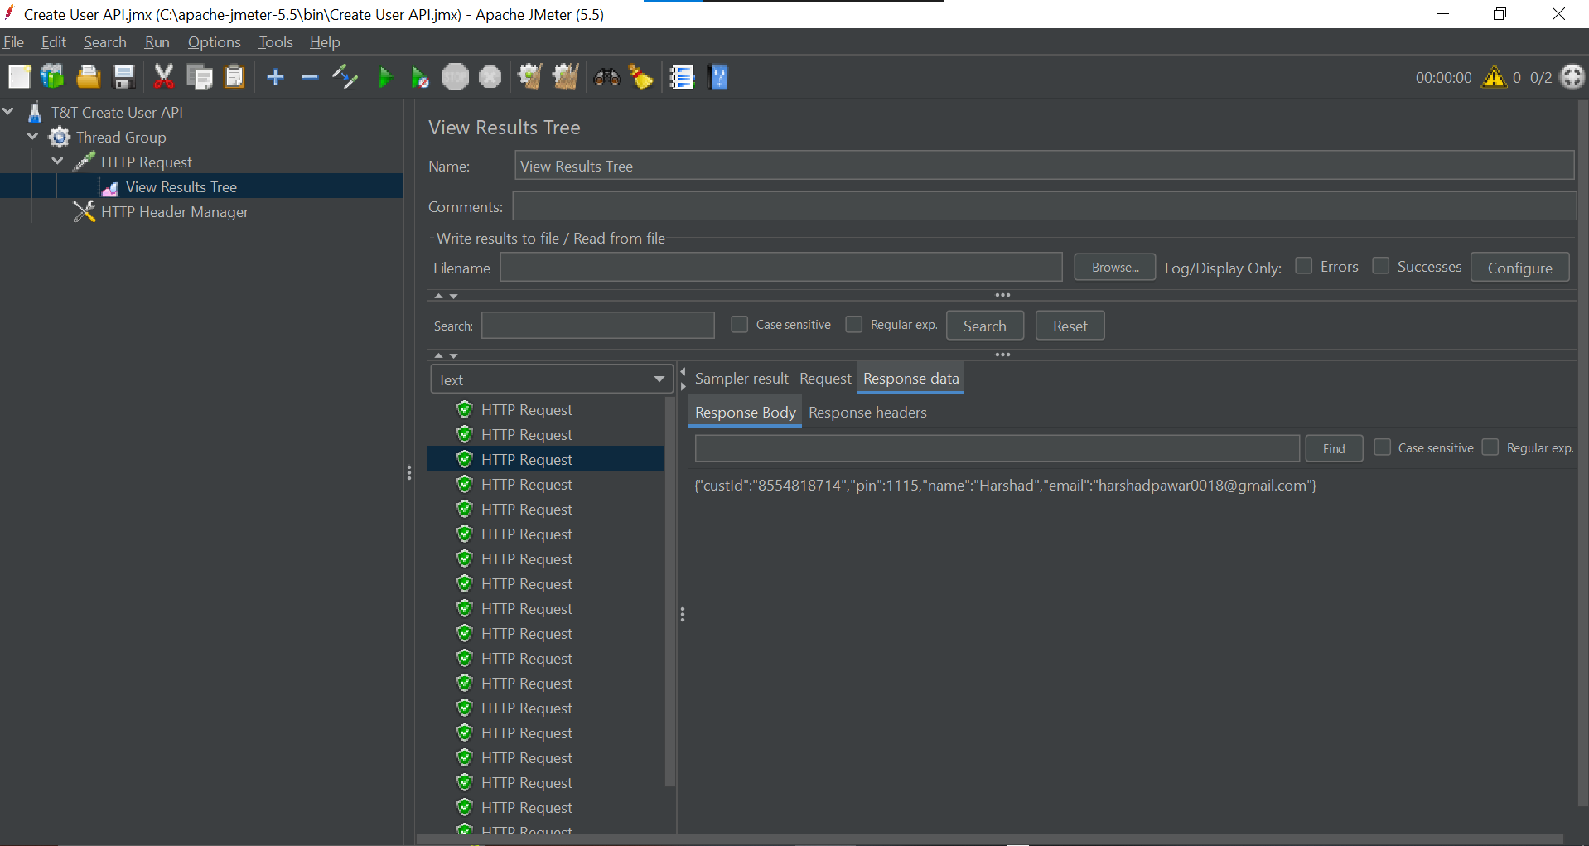

API Test for Book Packages (POST Method):

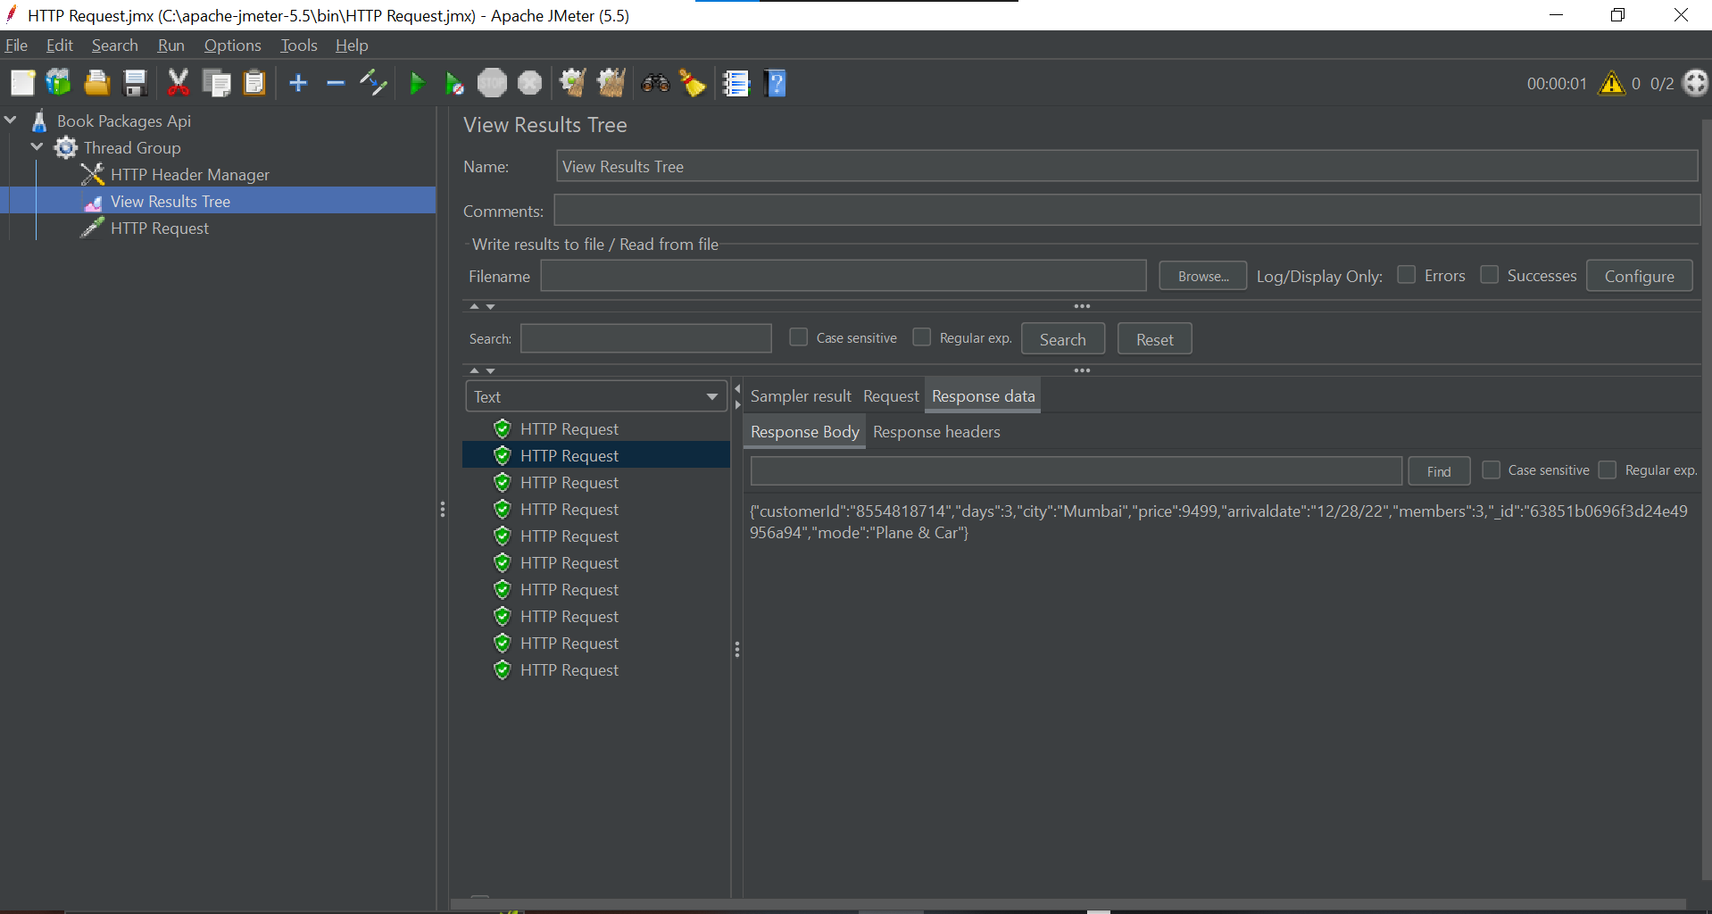

API test for add review:( POST Method)

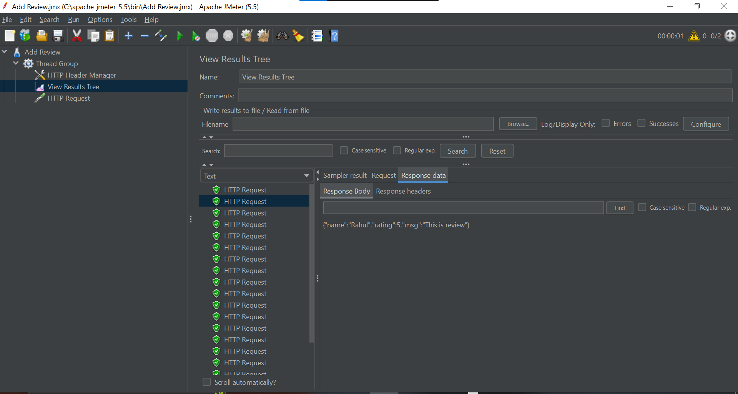

API test for Contact Us (POST Method):

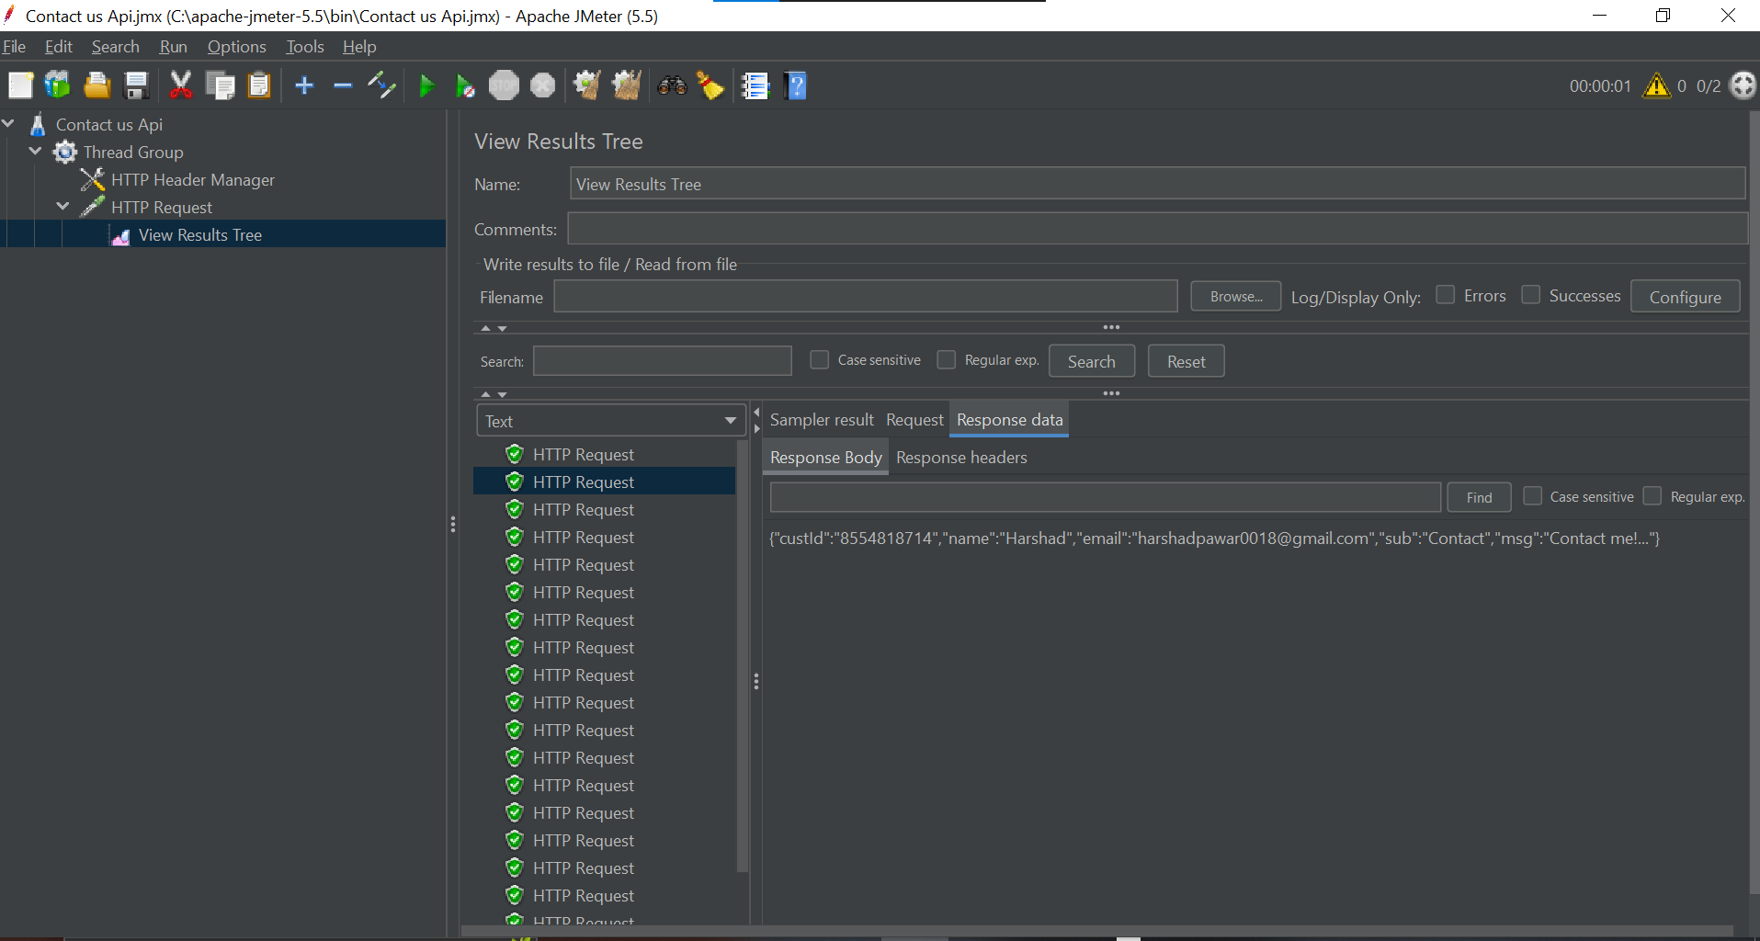

API test for View User Details (GET Method):

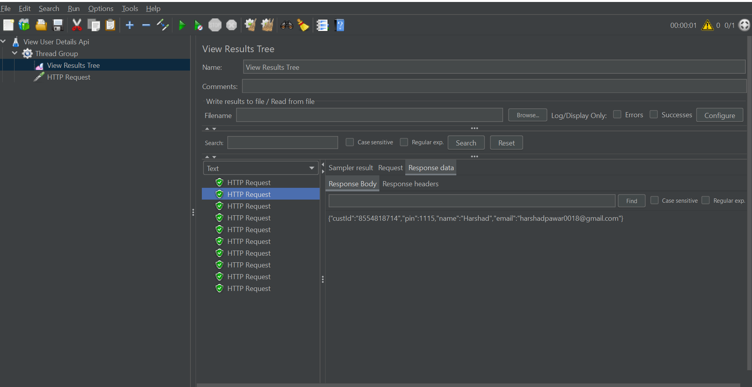

API test For View Booked Packages (GET Method):

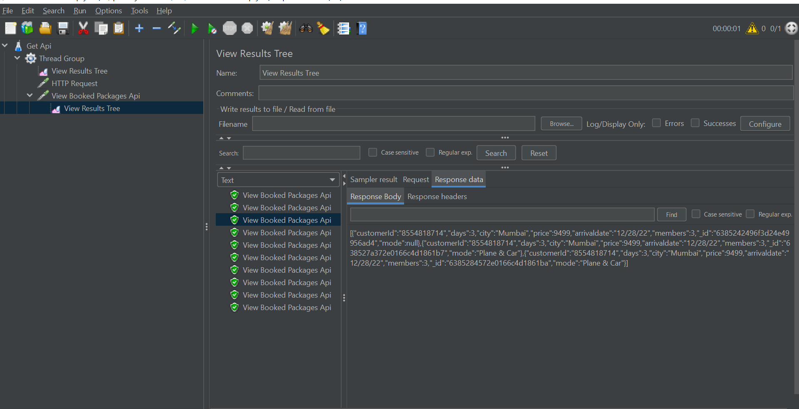

API test for View Review (GET Method):

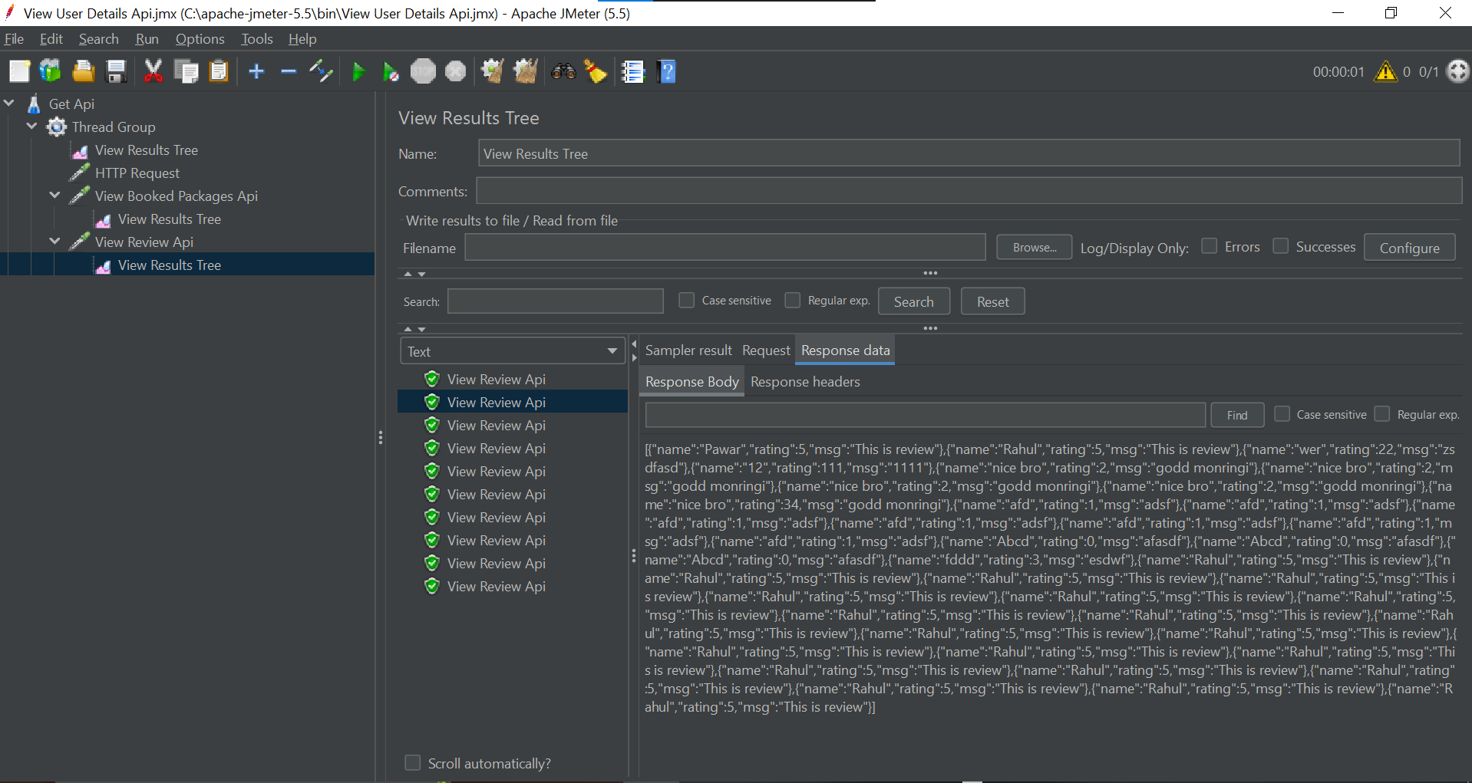

API test for Cancel Booking (DELETE Method):

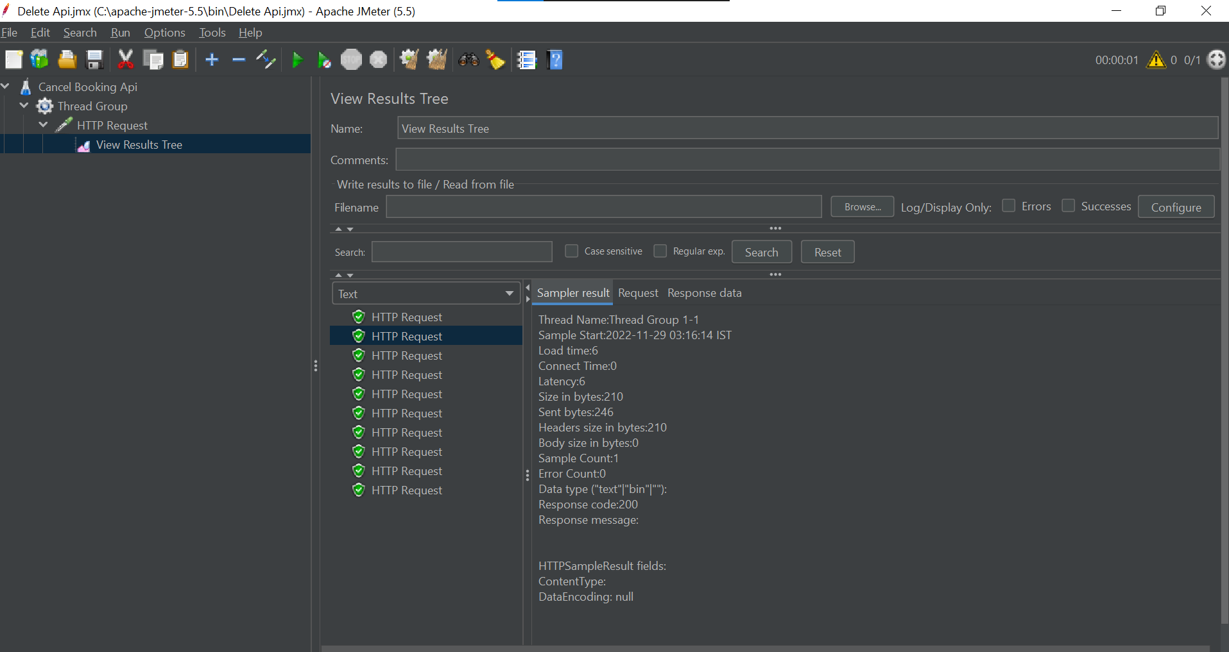

**Conclusion:**

I hope this project helped me learn the technology that used to develop a React Native application. By this project I Learned the Technology Like React Native, Mongo Db, Java.

Also got knowledge of how to use Jmeter to test API. In this project I learned How to develop the android application with all front end and backend operations. This Project give the complete Knowledge of this trending technologies.